Student: Tianlin He

Supervisor: Alexander Espinosa (alexander.espinosa@ki.se), Department of Medicine, Karolinska Institute, Stockholm.

Co-supervisor: William Nyberg (william.nyberg@ki.se), Department of Medicine, Karolinska Institute, Stockholm.

Starting date: 14 December 2017

*Content:* The report shall include: Cover page, Table of contents, Abstract, Introduction, Materials and Methods, Results, Discussion, Future work, Ethical reflection, Acknowledgements, References; Tables and Figures within these sections; and, if applicable, Appendices with raw data or computer program code. The maximum number of words is 10,000 and the report should be written in English.

**Project Title:**

**Mapping the dynamic interactome of the stimulated type I interferon receptor with proximity labeling and mass spectrometry**

1. **Aims and Objectives**

Type I interferons (IFN-I) is an important component of our innate immune system. They play critical roles in anti-viral and anti-microbial host defense, and are popular therapeutic agents and drug targets. In this study, we aim at drafting a dynamic interactome of the stimulated type I IFN receptor *in vitro*. The purpose is to understand the time-dependent downstream gene activation profile of type I IFN, and potentially, to identify new effectors in the IFN response that may provide new insight to translational medicine.

1. **Background**

Type I IFN are cytokines that are well known for their anti-viral and anti-proliferative activities. Recent studies also revealed that they exhibit potency in immunomodulation and immunostimulation. In human, there are altogether thirteen IFN subtypes, IFN, IFN that signal through the same evolutionarily conserved heterodimeric IFNAR receptor, suggesting that the functional importance of this structure. The receptor consists of two subunits, namely IFNAR1 and IFNAR2, both consists of an extracellular domain, a single transmembrane helix and a flexible cytoplasmic tail. The current model of human IFN-I system suggests that IFN first binds to IFNAR2, forming a binary IFNAR2/IFN complex. Receptor dimerization is induced by the initial ligand binding, hence a ternary IFNAR1/IFNAR2/IFN complex is assembled on the plasma membrane (Fig. 1).

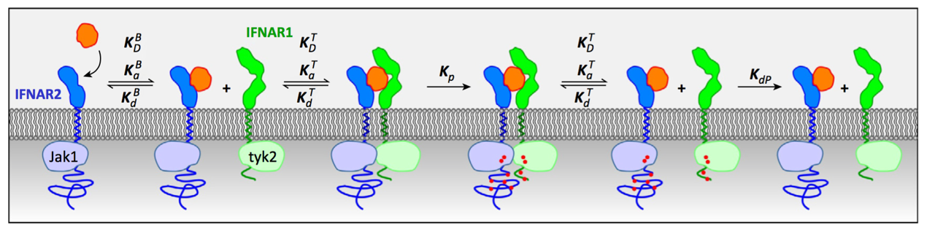

Fig. 1 Two-step assembly of ligand-induced IFNAR activation (putative). After ligand binding with IFNAR2, IFNAR1 is recruited to form a ternary complex. (G Schriber *et al.* 2015)

The cytoplasmic domain of the ternary complex is responsible for transducing the activation signal to nucleus, via a cascade of Janus kinase (JAK) and activator of transcription (STAT) signaling. Key effector molecules, such as pSTAT1/pSTAT2 heterodimer, have been identified along the signaling pathway. + timely manner

In pharmaceutical industry, IFNs are one of the most common therapeutic agents because of their potency and their crucial roles in controlling immune-related diseases. Despite their importance in immunity and widespread clinical use, the kinetics of IFNAR intracellular signaling is not completely understood.

Because of the crucial role of IFN signaling, there have been attempt

1. Microarray
2. Co-IP (from biocon)

But none of them deal with the kinetic of IFNAR1. Here, we propose the use of proximity label in combination with mass

Proximity labeling has two types….we use biotin, as it is non-toxic although it is slow. Recently, modification makes it quick….we make use of

Mass spec: quantification with SILAC (pic) raise the accuracy.

In this experiment, first use and confirm bioID2 for pilot study, then BASU. 1) compare with established list of genes 2) gene up-regulation 3) identify novel

1. **Methods**

**Proximity labeling with biotin ligase**

Proximity labeling has been a viable alternative to immunoprecipitation to study the interaction of biomolecules, such as proteins. BioID, the proximity dependent **Bio**tin **Id**entification makes use of a promiscuous bacterial biotin ligase. As illustrated in figures xa to xd, when the biotin ligase is fused to IFNAR1, it biotinylates the molecules in proximity. These proteins can be easily captured and isolated by streptavidin coated beads for further analysis. We first cloned the sequence of the biotin ligase, BioID2 at the 3’-end of IFNAR1, and expressed the fusion protein on HEK293T cell surface via retrovirus-mediated transduction. The design of the construct is illustrated below in Fig. 2.



Fig. 2 IFNAR1-Biotin ligase fusion protein that consists of a linker connecting IFNAR1 and BioID2, with a viral HA tag protein at the 3’end. Fusion protein expression is driven by retroviral promoter in 5’LTR, whereas SV40prom drives the expression of the puromycin resistance gene.

**IFN stimulation**

Transduced cells with IFNAR1-BioID2 expression will be incubated with biotin. Upon stimulation with type I IFN, the IFNAR1 receptor will be activated and initiate the signaling cascade by recruiting effector molecules. These molecules which will be tagged by biotin, by the biotin ligase BioID2 on the fusion protein. They will be collected, at different time point from 30 minutes to a few days, which corresponds to the effective time of IFN response suggested in the literature. The general procedures are illustrated in figures 3a to 3d. Untransduced cells with only endogenous IFNAR1 expression will be used as a control.

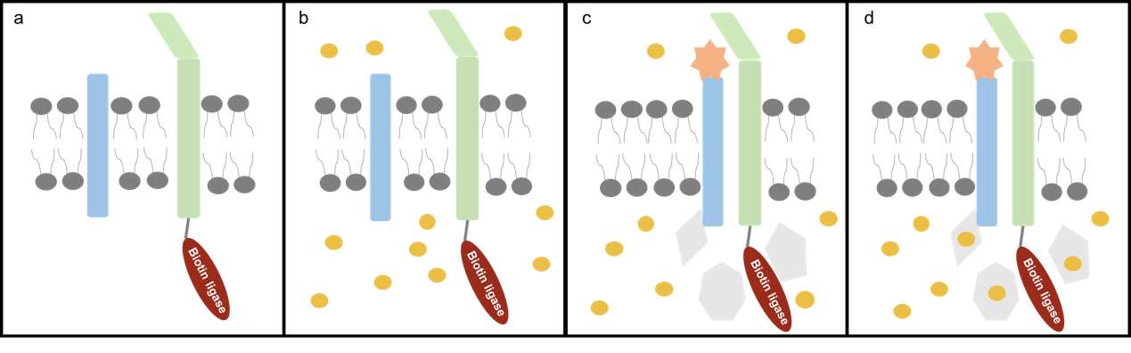

Fig. 3a) Assembly of BioID2-fusion IFNAR1 receptor on cell membrane. 3b) Incubation with biotin. 3c) IFN stimulation attracts effector molecules to the site. 3d) Biotin ligase activates biotin and conjugates them onto these effector molecules.

**Proteome analysis**

Both qualitative and quantitative methods will be used to study the proteome of the biotinylated proteins. After streptavidin-capture, purification and enrichment, these proteins will be blotted on a membrane, so that their variety and size can be visualized. Their protein profiles can also be compared across different time points after stimulation, as well as between samples and controls. They will also be examined for mass spectrometry analysis, which will illustrate both the identity and the relative quantity of the majority of proteins with label-free quantification. To minimize the technical variation due to handling of samples, SILAC (stable isotope labeling with amino acids in cell culture) reagents will be employed.

1. **Time table**

|  |  |
| --- | --- |
| 1. Verification of the IFNAR1-BioID construct by Western blot (WB) | 18V1 |
| 1. Generation of transduced IFNAR1-BioID cells | 17V54-18V2 |
| 1. Verification of the transduced cells    * Expression level of IFNAR by WB    * Cellular localization by FACS and fluorescence microscopy | 18V3-18V4 |
| 1. Pilot experiment:    * Incubate the transduced cells and controls in biotin    * Stimulation with IFN    * Isolation of biotinylated proteins after 18 hours    * WB (streptavidin-HRP) and WB (anti-HA)    * Send for liquid chromatography (LC) tandem mass spectrometry (MS/MS) | 18V5-18V7 |
| 1. Main experiment (after results from pilot experiment)    * Incubate the transduced cells and controls in biotin + SILAC    * Stimulation with IFN    * Isolation of biotinylated proteins at time point 0.5, 1, 2, 4, 18, 24 hours (need to be determined from pilot experiment)    * WB (whole biotinylated proteome) and WB (against STAT1)    * Send to LC-MS/MS | 18V10-18V11 |
| 1. MS spectral analysis    * Match spectra with peptide    * Match protein intensity    * Clustering analysis | 18V14-18V16 |